LAB: Public IP vs Elastic IP Validation

🎯 Lab Objective
- Create EC2 with auto-assigned Public IP
- Reboot instance → Check if IP changed
- Stop & Start → Check if IP changed
- Allocate Elastic IP
- Attach Elastic IP
- Reboot & Stop/Start
- Validate IP stability

🔹 Naming Convention
Resource | Name
EC2 | student-vm
Key Pair | student-key
Security Group | student-sg
Elastic IP | student-eip

🚀 STEP 1: Launch EC2 with Public IP
Go to:
AWS Console → EC2 → Launch Instance
Configuration
Setting | Value
Name | student-vm
AMI | Amazon Linux 2
Instance Type | t2.micro
Auto-assign Public IP | Enable
Key Pair | student-key
Security Group | student-sg (Allow SSH 22)
Click Launch
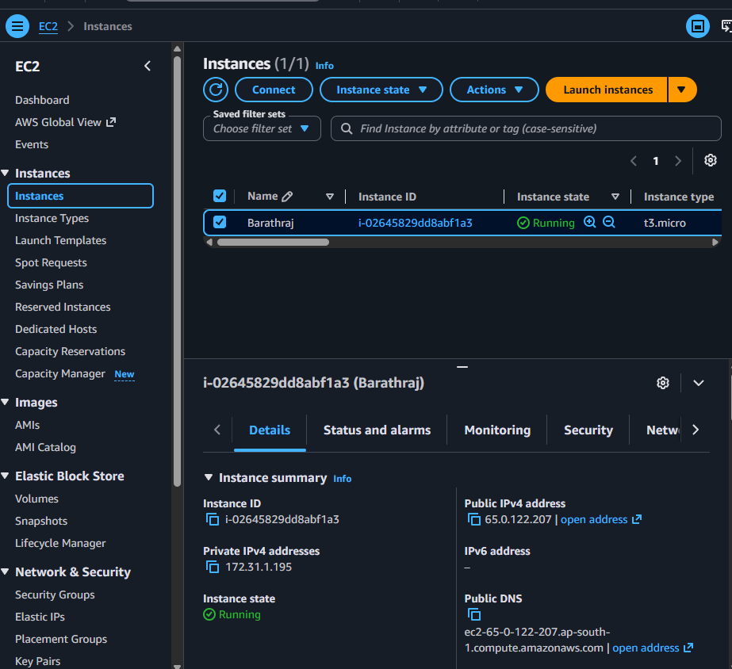

🔎 STEP 2: Check Public IP
Go to:
EC2 → Instances → student-vm
Note:
Public IPv4 address: xx.xx.xx.xx
Save this IP somewhere.
Public IP:65.0.122.207

🔁 STEP 3: Reboot Instance
Select instance → Instance State → Reboot
Wait until status checks pass.
Now check:
👉 Is Public IP changed?
✅ Answer: NO
Reboot does NOT change public IP.

🔴 STEP 4: Stop and Start Instance
Now do:
Instance State → Stop Wait until stopped
Then:
Instance State → Start
After instance is running → Check Public IP again.
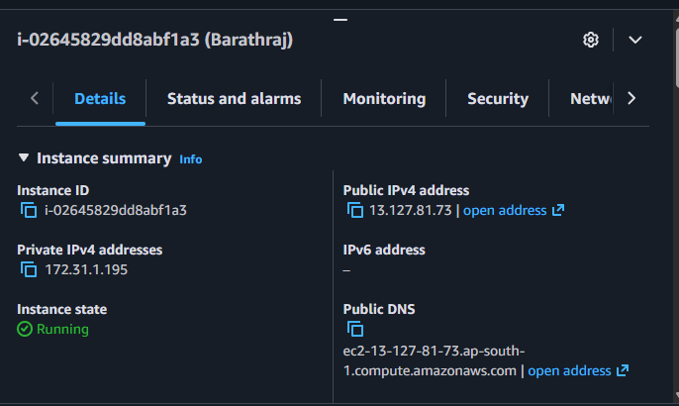

❓ Did Public IP Change?
✅ YES
When you Stop & Start, AWS releases auto-assigned public IP and assigns a new one.

📌 Observation Table
Action | Public IP Changes?
Reboot | ❌ No
Stop & Start | ✅ Yes

🌐 Why This Happens?
Auto-assigned public IP is temporary. When instance is stopped → IP is released.

🔒 STEP 5: Allocate Elastic IP
Go to:
EC2 → Elastic IPs → Allocate Elastic IP
Click Allocate
Name it:
student-eip
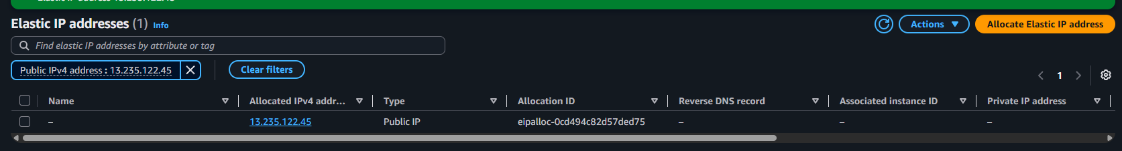

🔗 STEP 6: Attach Elastic IP
Select Elastic IP → Actions → Associate Elastic IP
Choose:
- Resource Type → Instance
- Instance → student-vm
- Private IP → Default
Click Associate
Now check instance → Public IP
It should now show the Elastic IP.
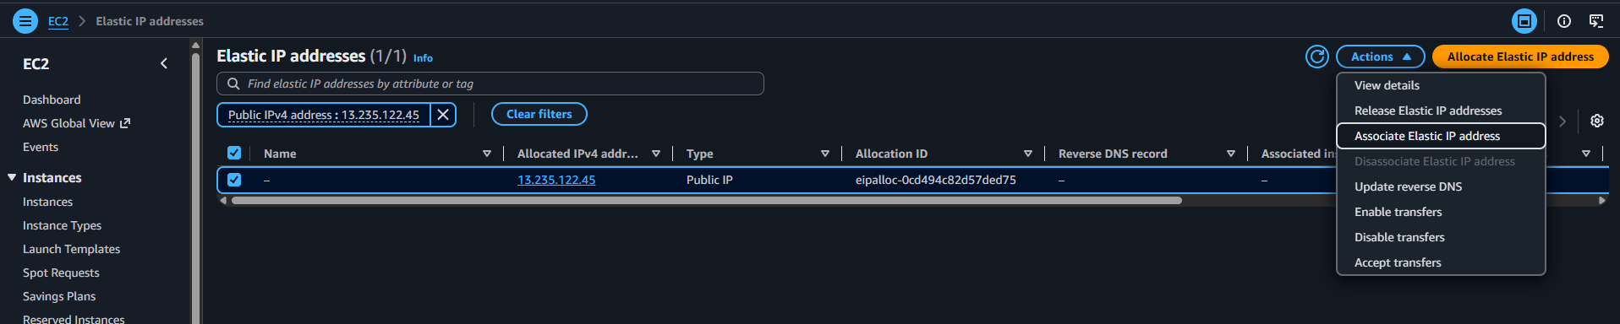
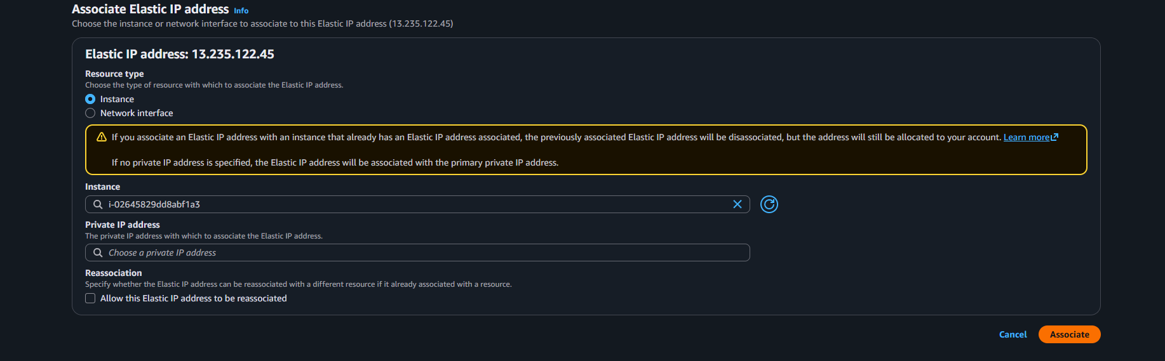

🔁 STEP 7: Reboot Instance
Reboot instance again.
Check Public IP.
✅ Elastic IP remains SAME.

🔴 STEP 8: Stop & Start Again
Stop instance Start instance
Check Public IP.
✅ Elastic IP remains SAME.
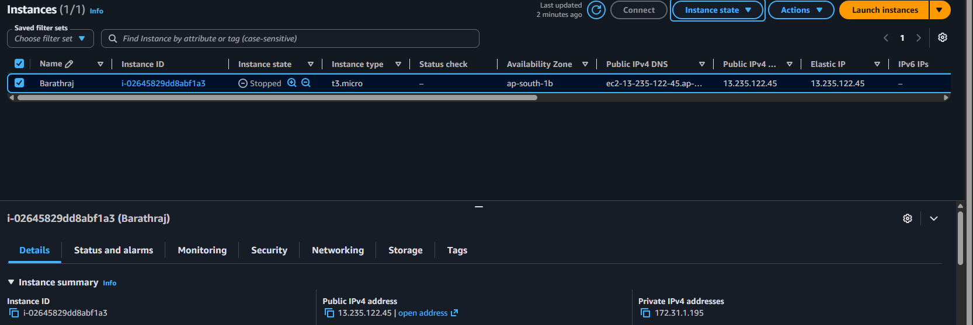
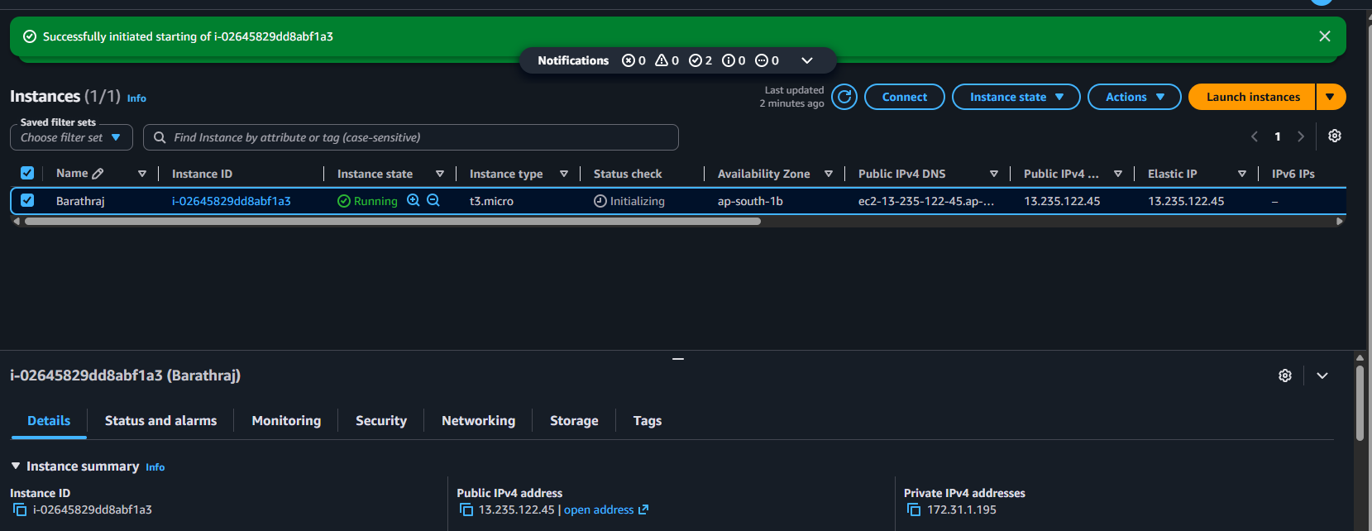

📊 Final Validation Table
Scenario | Auto Public IP | Elastic IP
Reboot | Same | Same
Stop/Start | Changes | Same
Recommended for Production | ❌ No | ✅ Yes

🧠 Important Concept
Elastic IP is:
👉 A static public IPv4 address 👉 Remains attached to your account 👉 Can be reassigned to another instance
Service used: Amazon Elastic IP

💰 Cost Note (Very Important)
Elastic IP is:
- FREE if attached to running instance
- Charged if NOT attached

🎯 Real-World Use Cases
- Production Web Server
- DNS mapping
- Firewall whitelisting
- Static external access

🏆 Final Learning Summary
Feature | Auto Public IP | Elastic IP
Static | ❌ No | ✅ Yes
Survives Stop/Start | ❌ No | ✅ Yes
Survives Reboot | ✅ Yes | ✅ Yes

